**QUIZZ**

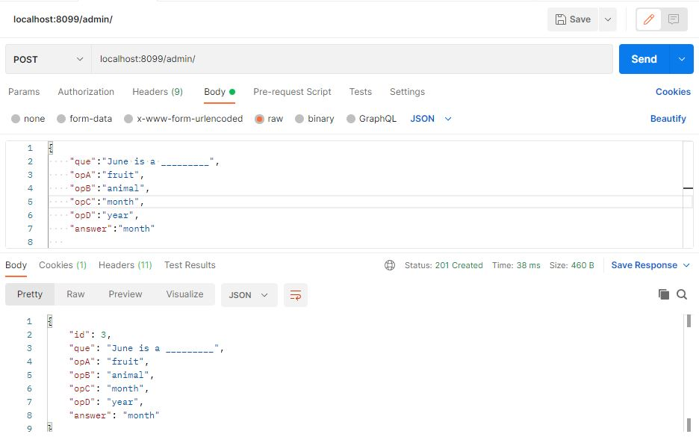

* Here all the data for the quiz question is added.
* Data are question, its options and answer.

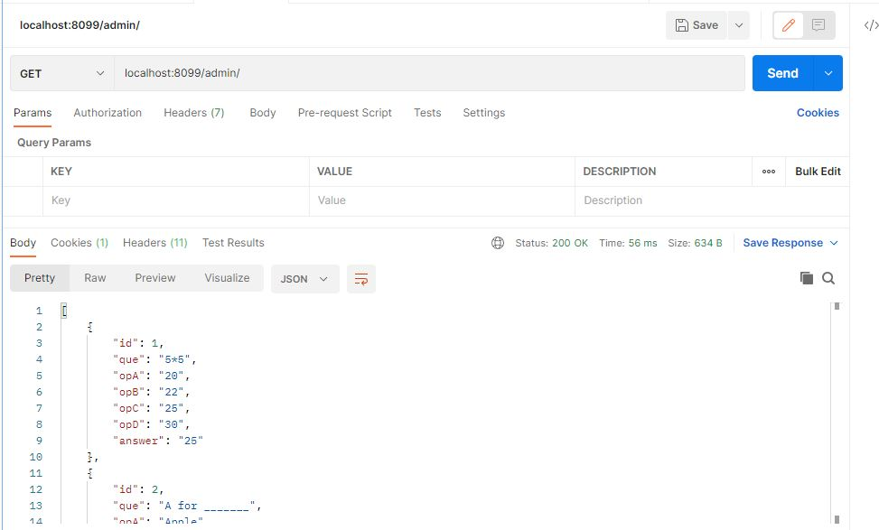

* Using get, added questions are displayed on screen

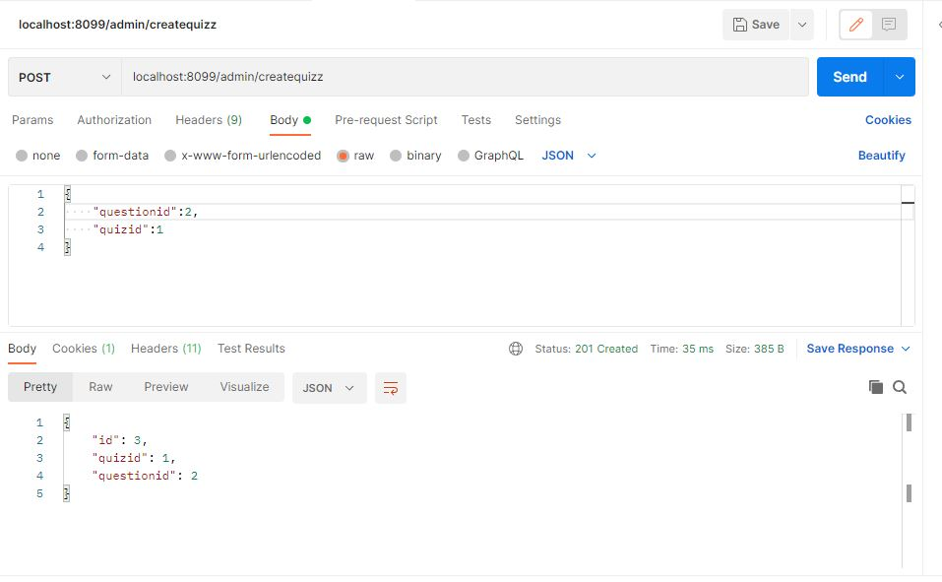

* Here questions are organized based on quiz id

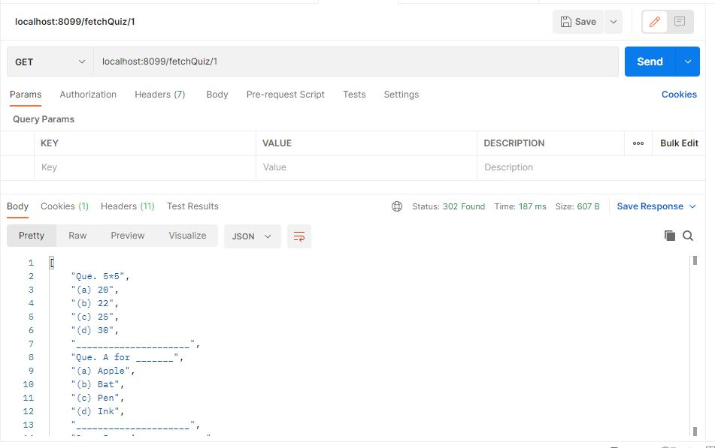

* Here questions are displayed based on quiz id.

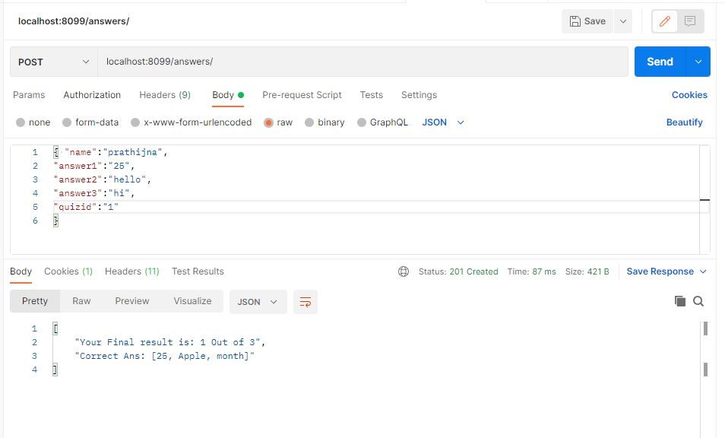

* Here user attempted the quiz
* Result is 1 out of 3 is correct.
* And correct answers are displayed.

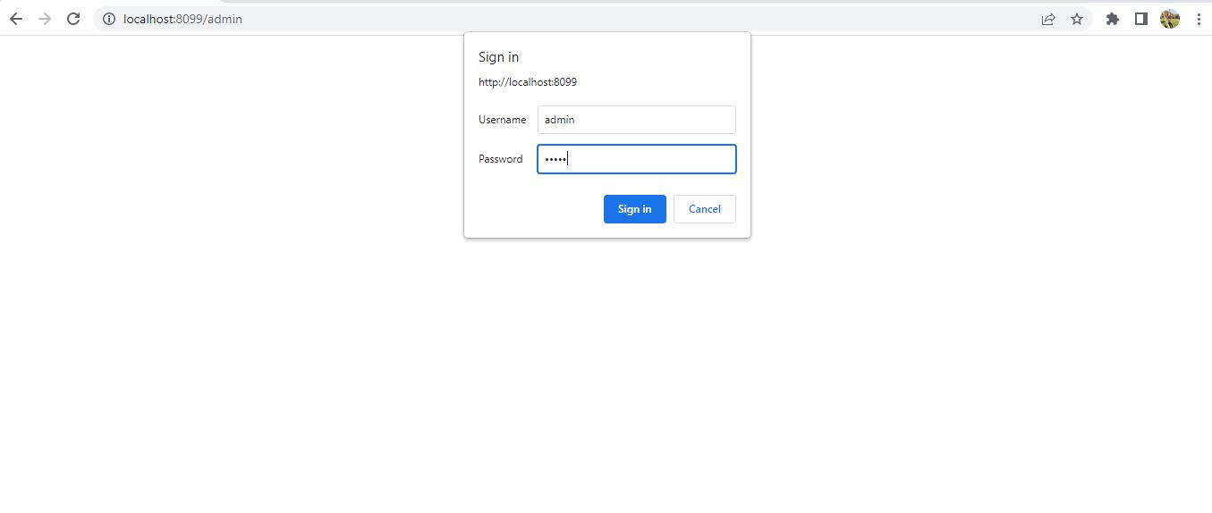

* User authentication and admin authentication is displayed.